IT 201 Final Project

Hospital database

Renee Holter

2019

Analysis

The hospital dataset is from the Corgi’s website[1]. The original dataset pulled information from patient surveys submitting by States and US Territories. I took a much smaller sampling of the data to make in more manageable by using a small sampling of the West Coast states (WA,OR, CA, ID, AK, and HI). The patient surveys are from post care at various facilities for a select group of procedures, two elective and two emergent. I removed extraneous columns from the original dataset as they were not pertinent for the project. Columns removed included mortality, effectiveness, timeliness, procedure value, just to name some of the columns. Issues with the dataset as is:

* There are some inconsistencies with the city/states. Washington DC is noted as City: Washington State: DC.
* Inconsistencies with the hospital/facility naming. There are some that are abbreviated or have a mix of capital letters.
* I added a couple of columns to the proc table better see the data and do some calculations.

Questions to answer from the dataset:

1. What are the hospital types?
2. What hospitals have a rating over 3?
3. What hospitals are in Seattle?
4. What is the Average cost of Heart Attack Care?
5. What are the hospitals with a Total Joint cost less that the maximum cost of total joints?

ER Diagram

Rating Hospital2 Proc Survey

RID HID PID SID   
overall h_name heart_attack name

Safety h_city heart_cost city

Readmit h_state total_joint state

Experience h_type tjoint_cost type

overall

safety ….

hid

rid

pid

Implementation

CREATE TABLE hospital2 (

hid int NOT NULL PRIMARY KEY AUTO_INCREMENT,

h_name varchar(150),

h_city varchar(90),

h_state varchar(2),

h_type varchar(30)

);

INSERT INTO hospital2 (h_name,h_city,h_state,h_type)

VALUES('Providence Alaska Medical Center','Anchorage','AK','Church')

INSERT INTO hospital2 (h_name,h_city,h_state,h_type)

VALUES('Mat-su Regional Medical Center','Palmer','AK','Unknown');

INSERT INTO hospital2 (h_name,h_city,h_state,h_type)

VALUES('St Rose Hospital','Hayward','CA','Church');

INSERT INTO hospital2 (h_name,h_city,h_state,h_type)

VALUES('St Joseph Hospital','Eureka','CA','Private');

INSERT INTO hospital2 (h_name,h_city,h_state,h_type)

VALUES('The Queens Medical Center','Honolulu','HI','Private');

INSERT INTO hospital2 (h_name,h_city,h_state,h_type)

VALUES('Maui Memorial Medical Center','Wailuku','HI','Government');

INSERT INTO hospital2 (h_name,h_city,h_state,h_type)

VALUES('Mid-columbia Medical Center','The Dalles','OR','Unknown');

INSERT INTO hospital2 (h_name,h_city,h_state,h_type)

VALUES('Providence St Vincent Medical Center','Portland','OR','Private');

INSERT INTO hospital2 (h_name,h_city,h_state,h_type)

VALUES('University Of Washington Medical Ctr','Seattle','WA','Government');

INSERT INTO hospital2 (h_name,h_city,h_state,h_type)

VALUES('Harborview Medical Center','Seattle','WA','Government');

INSERT INTO hospital2 (h_name,h_city,h_state,h_type)

VALUES('Swedish Issaquah','Issaquah','WA','Private');

INSERT INTO hospital2 (h_name,h_city,h_state,h_type)

VALUES('Providence Sacred Heart Medical Center','Spokane','WA','Church');

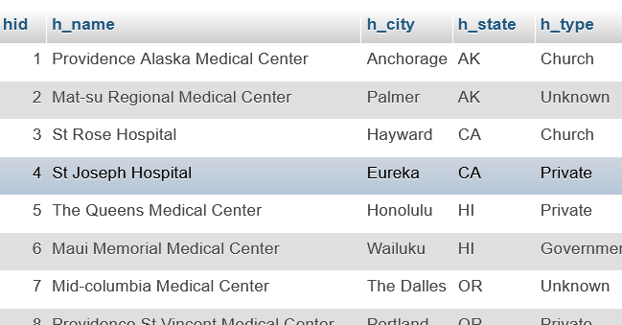

CREATE TABLE rating (

rid int NOT NULL PRIMARY KEY AUTO_INCREMENT,

overall int,

safety varchar(20),

readmit varchar(20),

experience varchar(20)

);

insert into rating values

(1, '4','Above','Above','Same')

(2, '3','Same','Above','Same'),

(3,'2’,’Above','Below','Below'),

(4,'2’,’Below','Above','Below'),

(5,'5’,’Above','Above','Above'),

(6,'3’,’Above','Above','Below'),

(7,'3’,’Above','Above','Same '),

(8,'4’,’Above','Above','Above'),

(9,'4’,’Above','Above','Above'),

(10,'3','Same','Below','Same'),

(11,'4','Above','Below','Above'),

(12,'4','Above','Above','Same');

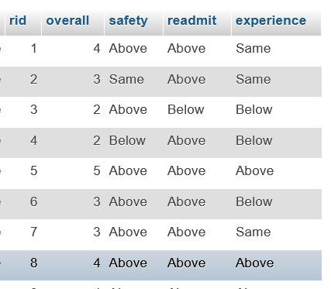

CREATE TABLE proc (

pid int NOT NULL PRIMARY KEY AUTO_INCREMENT,

heart_attack varchar(20),

heart_cost decimal(8,2),

total_joint varchar(10),

tjoint_cost decimal(8,2)

)

INSERT INTO proc VALUES

(1,'True','23,925','True','$19,274.00'),

(2,'True','$21,695.00','True','$18,669.00'),

(3,'True','$27,618.00','True','$26,462.00'),

(4,'True,','$21,152.00','True','$18,464.00'),

(5,'True','$20,433.00','True','$19,597.00'),

(6,'True','$21,048.00','False','$0.00'),

(7,'False','$0.00','True','$20,230.00'),

(8,'True','$22,236.00','True','$17,610.00'),

(9,'True','$24,463.00','True','$23,475.00'),

(10,'True','$24,660.00','False','$0.00');

(11,'True','$22,700.00','True','$20,775.00'),

(12,'True','$22,082.00','True','$20,534.00');

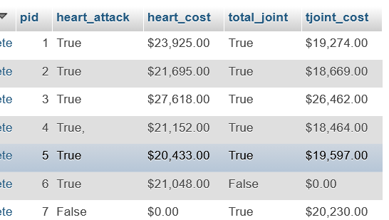

CREATE TABLE survey (

sid int NOT NULL PRIMARY KEY,

name varchar(150),

city varchar(20),

state varchar(2),

type varchar(20),

overall varchar(20),

safety varchar(20),

readmit varchar(20),

experience varchar(20),

heart_attack varchar(10),

heart_cost decimal(8,2),

total_joint varchar(20),

tjoint_cost decimal(8,2),

hid int NOT NULL,

FOREIGN KEY (hid) REFERENCES hospital2(hid),

rid int NOT NULL,

FOREIGN KEY (rid) REFERENCES rating(rid),

pid int NOT NULL,

FOREIGN key (pid) REFERENCES proc(pid));

INSERT INTO survey VALUES

(1,'Providence Alaska Medical Center','Anchorage','AK','Church','4','Above','Above','Same','True',23925,'True',19274,1,1,1),

(2,'Mat-su Regional Medical Center','Palmer','AK','Unknown','3','Same','Above','Same','True',21695,'True',18669,2,2,2),

(3,'St Rose Hospital','Hayward','CA','Church','2','Above','Below','Below','True',27618,'True',26462,3,3,3),

(4,'St Joseph Hospital','Eureka','CA','Private','2','Below','Above','Below','True',21152,'True',18464,4,4,4),

(5,'The Queens Medical Center','Honolulu','HI','Private','5','Above','Above','Above','True',20433,'True',19597,5,5,5),

(6,'Maui Memorial Medical Center','Wailuku','HI','Government','3','Above','Above','Below','True',21048,'False',0,6,6,6),

(7,'Mid-columbia Medical Center','The Dalles','OR','Unknown','3','Above','Above','Same','False','$0.00','True',20230,7,7,7),

(8,'Providence St Vincent Medical Center','Portland','OR','Private','4','Above','Above','Above','True',22236,'True',17610,8,8,8),

(9,'University Of Washington Medical Ctr','Seattle','WA','Government','4','Above','Above','Above','True',24463,'True',23475,9,9,9),

(10,'Harborview Medical Center','Seattle','WA','Government','3','Same','Below','Same','True',24660,'False',0,10,10,10),

(11,'Swedish Issaquah','Issaquah','WA','Private','4','Above','Below','Above','True',22700,'True',20775,11,11,11),

(12,'Providence Sacred Heart Medical Center','Spokane','WA','Church','4','Above','Above','Same','True',22082,'True',20534,12,12,12)

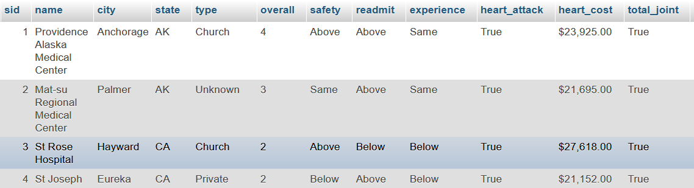

Utilization

Answers the previous questions

1. What are the hospital types? Church, Government, Private, and unknown. Hospitals can have church/religious affiliations. Government means they are either public hospitals or military ran.

SELECT h.h_type, count(h.h_type)

from hospital2 h

GROUP by h.h_type

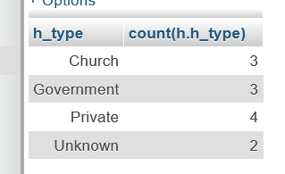

1. What hospitals have a rating over 3?

SELECT h.h_name,r.overall

FROM hospital2 h, rating r, survey s

WHERE h.hid = s.hid and r.rid = s.rid

and r.overall > 3

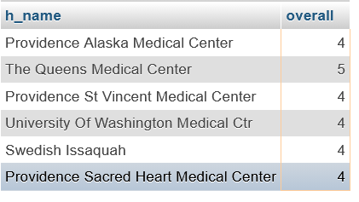

1. What Hospitals are based in Seattle?

SELECT h.h_name,h.h_city

FROM hospital2 h

WHERE h.h_city like '%Se%'

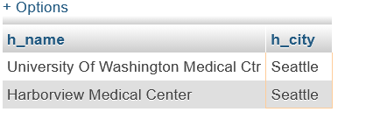

1. What is the Average cost of Heart Attack Care?

SELECT avg(p.heart_cost)

FROM proc p, survey s, hospital2 h

Where h.hid = s.hid and s.pid = p.pid

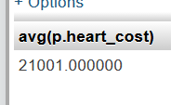

1. What are the hospitals with a Total Joint cost less that the maximum cost of total joints?

SELECT DISTINCT h.h_name, p.tjoint_cost

from hospital2 h, proc p, survey s

WHERE h.hid = s.hid

AND p.pid = s.pid

AND (p.tjoint_cost < (select max(p.tjoint_cost)

FROM proc p ))

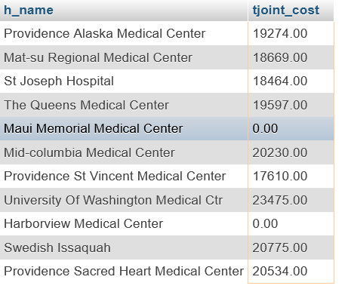

1. What are the top 5 of the hospitals from the previous question?

SELECT DISTINCT h.h_name, p.tjoint_cost

from hospital2 h, proc p, survey s

WHERE h.hid = s.hid

AND p.pid = s.pid

AND (p.tjoint_cost < (select max(p.tjoint_cost)

FROM proc p ))

LIMIT 5

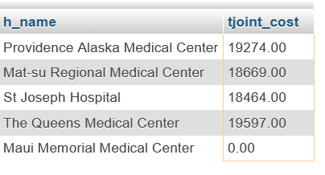

Edit statement that that edits a row.

update proc

set tjoint_cost = 18464

Where pid = 4;

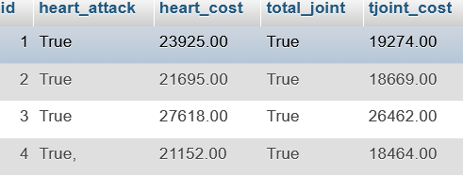

1. https://corgis-edu.github.io/corgis/csv/